Unit 15 Assignment Instructions – CIS164 
For the Unit 15 Assignment we will be using Python for our Final Project to show the skills you have learned throughout the course!
Please make sure to fully read each question to ensure that you answer each question per the requirement. Also, please ensure that all responses are in complete sentences, free of spelling and grammatical errors.
*Unit 15 Grading Rubric (150 Points):
Assignment Requirements | Maximum Points | Points Earned
1. Task 1 | 0-20 Points
2. Task 2 | 0-30 Points
3. Task 3 | 0-40 Points
4. Task 4 | 0-60 Points
Points Deducted for Spelling or Grammatical Errors
Total (Sum of All Points)
*Directions for Submitting Your Assignment:
Complete your assignment ensuring all questions are answered based on the assignment requirements. When the Unit 15 assignment is complete, please save your file in the following format, “Lastname-Unit#.doc” (Example: Smith-Unit15.doc). You may also utilize a Word Processing software such as LibreOffice for assignment completion. In this case the assignment may be saved in .odt format, (Example: Smith-Unit15.odt). Then when ready submit your file to the “CIS 164 – Unit 15 Submit Assignment” activity for grading.

1. Task 1
- Start the PyCharm IDE. Select “File->New Project” on the next screen, then under “Location” change the word “untitled” to “Unit15”. Then click the “Create” button.

- Highlight your project “Unit15” then right click. When you right click a menu will appear, from this menu select New->Python File. Then a dialog box will appear, in the “Name” field of the dialog box type “Unit15_Task1.py”.

- For your script, you will need to ask a user for an unknown number of names (one at a time) and give the user a way to let your script know they are done entering names.

- The names entered by the user should be stored in a List. You will need to print out the contents of the list. Then you will need to take the List and sort it and display it. You will then need to take the sorted List and display it reverse order.

- For your script, you will need to provide a screenshot showing your completed script being run, and you will also need to submit it in a text file, along with this document.

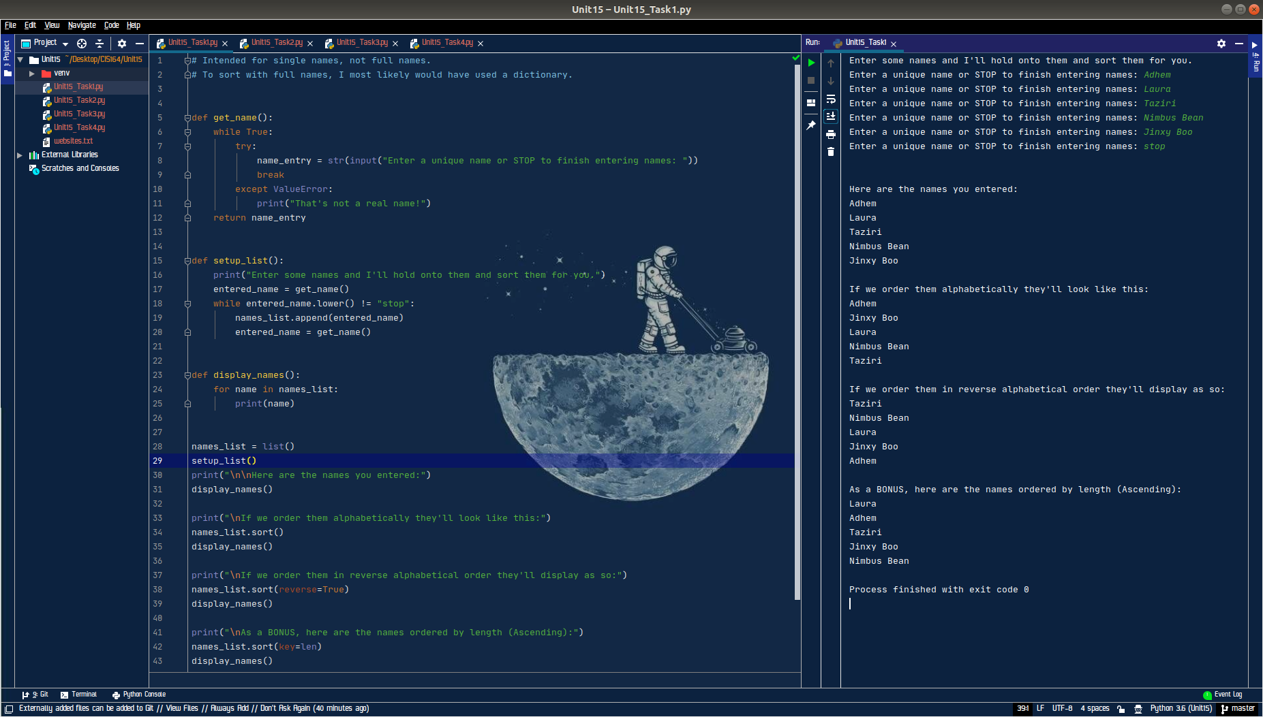

2. Task 2
- Highlight your project “Unit15” then right click. When you right click a menu will appear, from this menu select New->Python File. Then a dialog box will appear, in the “Name” field of the dialog box type “Unit15_Task2.py”.

- You will be provided a text file, which is in our Moodle classroom under Unit 15 titled ‘websites.txt’.

- For your script, you will need to loop through the file line by line with a for loop and open each website listed within the file within the browser with the use of the webbrowser library. Note: Do not use threading for this task!

- For your script, you will need to provide a screenshot showing your completed script being run, and you will also need to submit it in a text file, along with this document.

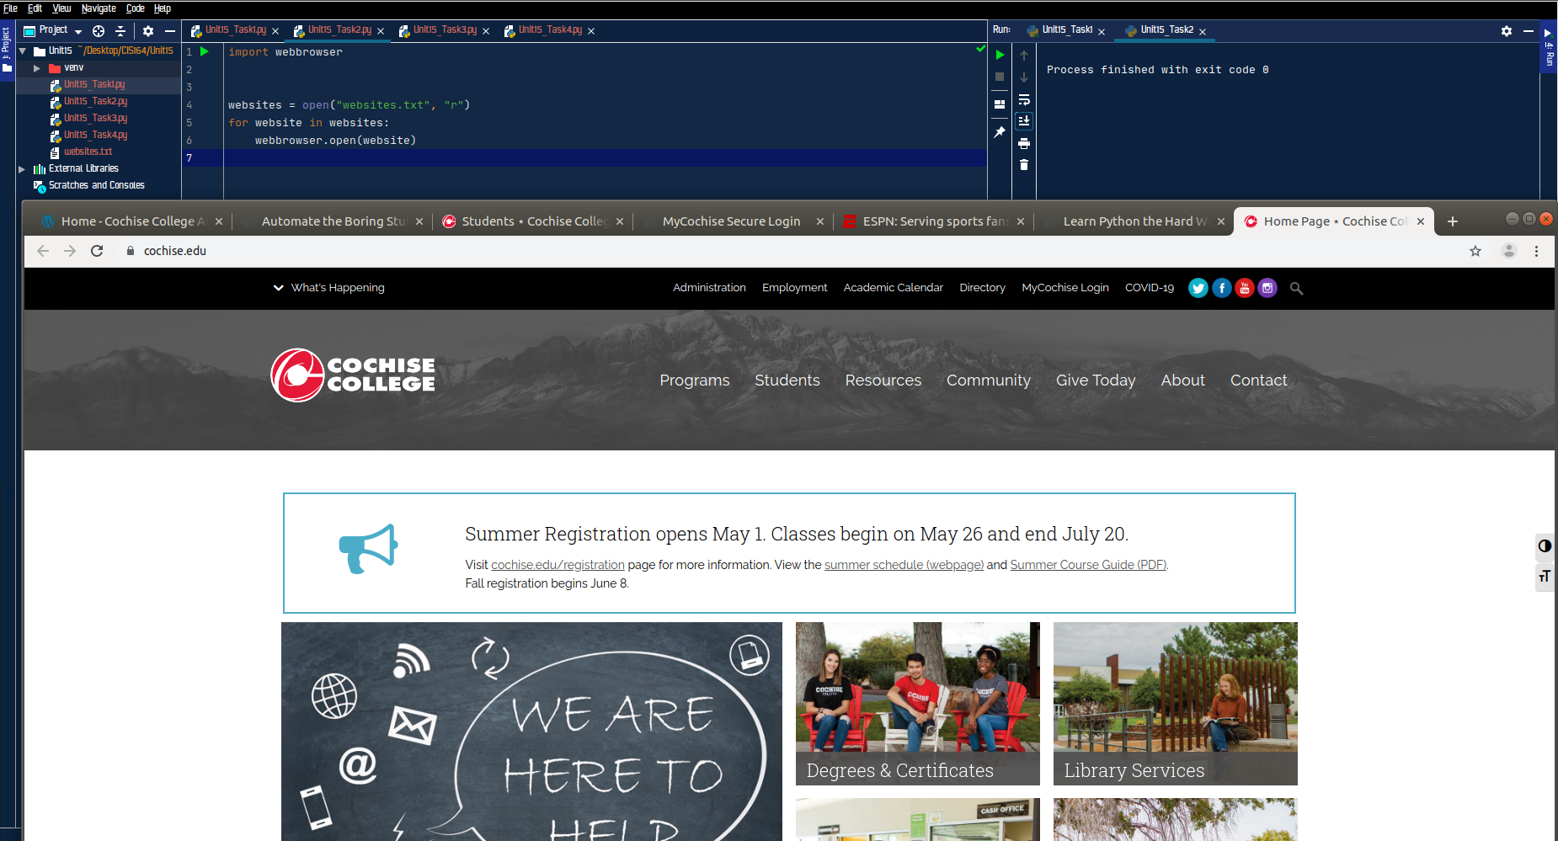

3. Task 3
- Highlight your project “Unit15” then right click. When you right click a menu will appear, from this menu select New->Python File. Then a dialog box will appear, in the “Name” field of the dialog box type “Unit15_Task3.py”.

- Create a script that allows a user to enter a desired password length. Then based on the desired password length, create a random password for the user with uppercase characters, lowercase characters, digits, and special characters.

- For your script, you will need to provide a screenshot showing your completed script being run showing a password length of at least 20 characters, and you will also need to submit it in a text file, along with this document.

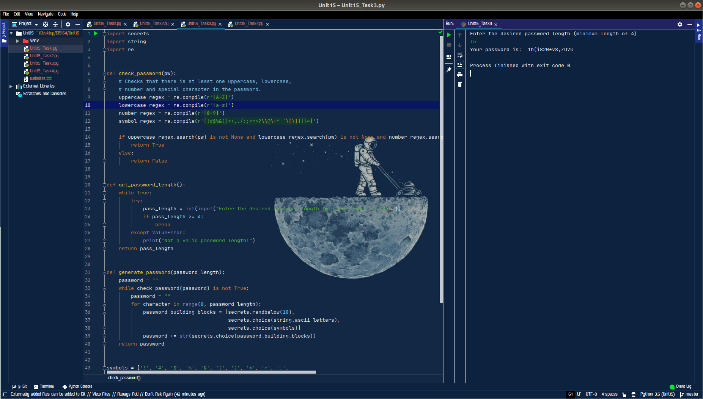

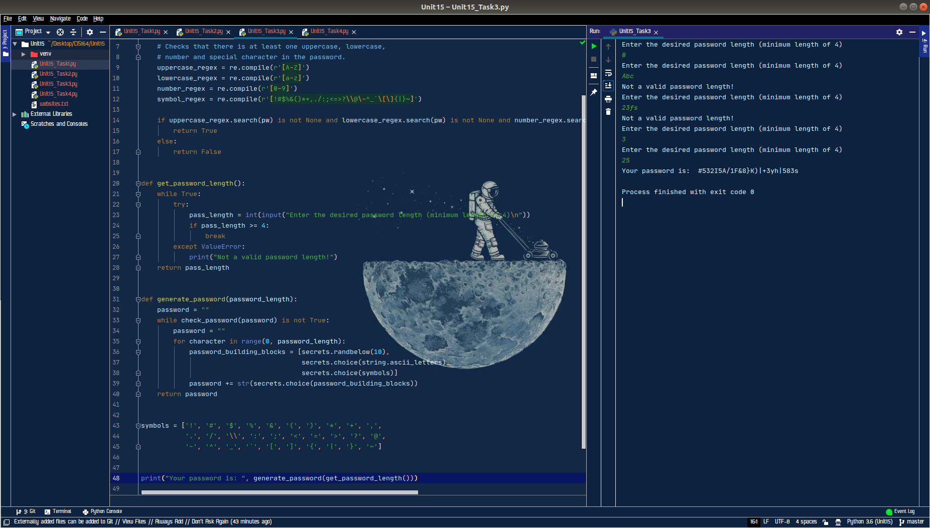

4. Task 4
- Highlight your project “Unit15” then right click. When you right click a menu will appear, from this menu select New->Python File. Then a dialog box will appear, in the “Name” field of the dialog box type “Unit15_Task4.py”.

- Create a script that uses a menu system to ask the user if they want to run the following:

1. Calculator (Note: gnome-calculator)
2. Text Editor (Note: gedit)
3. Web Browser (Note: firefox)
4. Quit Menu

- Your menu must also display the current date and time in an appropriate format. The menu system should also handle incorrect entries appropriately.

- For your script, you will need to provide a screenshot showing your completed script run, and you will also need to submit it in a text file, along with this document.
